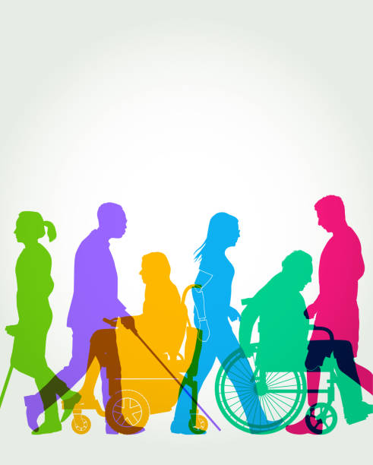
The experience of my father’s disability led me to becoming a Reform rabbi. What do our texts teach us about our attitudes to the disabled, either in body or in mind? Where our tradition seems to lack modern sensibilities towards the rights and needs of disabled people, can we/should we modify those attitudes?

Special, special needs, disabled….which is the most acceptable term for us to use?

The terms “special” and “special needs” do not serve our cause. . . We need to
embrace the term “disability” as a fact of life in olam hazeh (this world). We want
society at large to continue to increase its regard for us as “people with disabilities,”
an identifiable and broad demographic, who can contribute to the destiny, well-being,
and growth of klal Yisroel, if we’re provided the right accommodation.
Sharon Shapiro-Lacks, “‘Special’ Does Not a Disability Make.”

My needs are not “special” just because they’re not met in ways identical to the needs of nondisabled people. I need a ramp; you need steps. Not special, just facts. I need a wheelchair;
you walk. Not special, just facts. Moreover, the needs of non-disabled people certainly aren’t
all met in the same ways. Just like every other living, breathing human being on this planet, I
am a person who has needs that must be fulfilled in ways appropriate to my abilities.
Emily Ladau, ”Four Disability Euphemisms that Need to Bite the Dust”

We know words can hurt or heal. Why have these authors both chosen to use the word ‘disabled’ rather than ‘special’?
Thinking of our renowned ancestors in the Torah, what disabilities did they have? How did it affect their lives?
What is the difference between a mental illness and an intellectual disability? When considering ritual and legal situations, should we distinguish between these two categories. Where should we be drawing lines? If anywhere?
Texts that discriminate against the disabled.
In Ritual Matters: the priesthood.
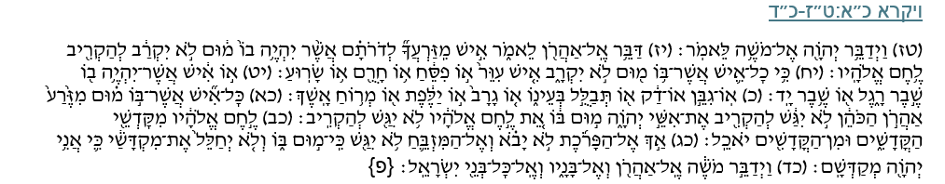
Leviticus 21:16-24
יהוה(16) spoke further to Moses: (17) Speak to Aaron and say: No man of your offspring throughout the ages who has a defect shall be qualified to offer the food of his God. (18) No one at all who has a defect shall be qualified: no man who is blind, or lame, or has a limb too short or too long; (19) no man who has a broken leg or a broken arm; (20) or who is a hunchback, or a dwarf, or who has a growth in his eye, or who has a boil-scar, or scurvy, or crushed testes. (21) No man among the offspring of Aaron the priest who has a defect shall be qualified to offer יהוה’s offering by fire; having a defect, he shall not be qualified to offer the food of his God. (22) He may eat of the food of his God, of the most holy as well as of the holy; (23) but he shall not enter behind the curtain or come near the altar, for he has a defect. He shall not profane these places sacred to Me, for I יהוה have sanctified them. (24) Thus Moses spoke to Aaron and his sons and to all the Israelites.
מגילה כ״ד ב:ח׳
מַתְנִי׳ כֹּהֵן שֶׁיֵּשׁ בְּיָדָיו מוּמִין לֹא יִשָּׂא אֶת כַּפָּיו. רַבִּי יְהוּדָה אוֹמֵר: אַף מִי שֶׁהָיוּ יָדָיו צְבוּעוֹת סְטֵיס לֹא יִשָּׂא אֶת כַּפָּיו, מִפְּנֵי שֶׁהָעָם מִסְתַּכְּלִין בּוֹ.
Megillah 24b:8
MISHNA: A priest who has blemishes on his hands may not lift his hands. Rabbi Yehuda says: Even one whose hands were coloured with satis, a blue dye, may not lift his hands because the congregation will look at him.
מגילה כ״ד ב:ט׳-י״ד
גְּמָ׳ תָּנָא: מוּמִין שֶׁאָמְרוּ, בְּפָנָיו יָדָיו וְרַגְלָיו. אָמַר רַבִּי יְהוֹשֻׁעַ בֶּן לֵוִי: יָדָיו בּוֹהֲקָנִיּוֹת — לֹא יִשָּׂא אֶת כַּפָּיו. תַּנְיָא נָמֵי הָכִי: יָדָיו בּוֹהֲקָנִיּוֹת — לֹא יִשָּׂא אֶת כַּפָּיו. עֲקוּמּוֹת עֲקוּשׁוֹת — לֹא יִשָּׂא אֶת כַּפָּיו. אָמַר רַב אַסִּי: חֵיפָנִי וּבֵישָׁנִי — לֹא יִשָּׂא אֶת כַּפָּיו. תַּנְיָא נָמֵי הָכִי: אֵין מוֹרִידִין לִפְנֵי הַתֵּיבָה לֹא אַנְשֵׁי בֵּית שְׁאָן וְלֹא אַנְשֵׁי (בֵּית) חֵיפָה וְלֹא אַנְשֵׁי טִבְעוֹנִין, מִפְּנֵי שֶׁקּוֹרִין לָאַלְפִין עַיְינִין וְלָעַיְינִין אַלְפִין. אֲמַר לֵיהּ רַבִּי חִיָּיא לְרַבִּי שִׁמְעוֹן בַּר רַבִּי: אִלְמָלֵי אַתָּה לֵוִי — פָּסוּל אַתָּה מִן הַדּוּכָן, מִשּׁוּם דַּעֲבֵי קָלָךְ. אֲתָא אֲמַר לֵיהּ לַאֲבוּהּ. אֲמַר לֵיהּ: זִיל אֵימָא לֵיהּ: כְּשֶׁאַתָּה מַגִּיעַ אֵצֶל ״וְחִכִּיתִי לַה׳״, לֹא נִמְצֵאת מְחָרֵף וּמְגַדֵּף?! אָמַר רַב הוּנָא: זַבְלְגָן לֹא יִשָּׂא אֶת כַּפָּיו. וְהָא הַהוּא דַּהֲוָה בְּשִׁיבָבוּתֵיהּ דְּרַב הוּנָא, וַהֲוָה פָּרֵיס יְדֵיהּ! הָהוּא דָּשׁ בְּעִירוֹ הֲוָה. תַּנְיָא נָמֵי הָכִי: זַבְלְגָן לֹא יִשָּׂא אֶת כַּפָּיו, וְאִם הָיָה דָּשׁ בְּעִירוֹ — מוּתָּר. אָמַר רַבִּי יוֹחָנָן: סוֹמֵא בְּאַחַת מֵעֵינָיו — לֹא יִשָּׂא אֶת כַּפָּיו. וְהָא הַהוּא דַּהֲוָה בְּשִׁיבָבוּתֵיהּ דְּרַבִּי יוֹחָנָן דַּהֲוָה פָּרֵיס יְדֵיהּ! הָהוּא דָּשׁ בְּעִירוֹ הֲוָה. תַּנְיָא נָמֵי הָכִי: סוֹמֵא בְּאַחַת מֵעֵינָיו — לֹא יִשָּׂא אֶת כַּפָּיו, וְאִם הָיָה דָּשׁ בְּעִירוֹ — מוּתָּר. רַבִּי יְהוּדָה אוֹמֵר: מִי שֶׁהָיוּ יָדָיו צְבוּעוֹת — לֹא יִשָּׂא אֶת כַּפָּיו. תָּנָא: אִם רוֹב אַנְשֵׁי הָעִיר מְלַאכְתָּן בְּכָךְ — מוּתָּר.
Megillah 24b:9-14
GEMARA: It is taught: The blemishes that the Sages said disqualify a priest are on his face, hands, and feet. Rabbi Yehoshua ben Levi said: If his hands are spotted, he may not lift his hands. This is also taught: his hands are spotted, he may not lift his hands, if curved or bent, he may not lift his hands.
Rav Asi said: from Haifa or Beit She’an may not lift his hands. This is also taught: One may not allow the people of Beit She’an, nor the people of Beit Haifa, nor the people of Tivonin to pass before the ark because they pronounce alef as ayin and ayin as alef.
Rabbi Chiyya once said to Rabbi Shimon, son of Rabbi: If you were a Levite, you would be disqualified from the platform because your voice is thick. Rabbi Shimon went and told his father, who said to him: Go and say to him: When you study and reach the verse: “And I will wait upon [veḥikkiti] the Eternal” (Isaiah 8:17), will you not be a maligner and a blasphemer?
Rav Huna said: A priest whose eyes run may not lift his hands. Wasn’t there a certain priest with this condition in the neighbourhood of Rav Huna, and he would spread his hands? That priest was a familiar figure in his town.
This is also taught: One whose eyes run should not lift his hands but if he is a familiar figure in his town, he is permitted.
Rabbi Yochanan said: One who is blind in one eye may not lift his hands. Wasn’t there a certain priest who was blind in one eye in the neighbourhood of Rabbi Yochanan, and he would lift his hands? That priest was a familiar figure in his town. This is also taught: One who is blind in one eye may not lift his hands, but if he is a familiar figure in his town, he is permitted.
Rabbi Yehuda said: One whose hands are coloured should not lift his hands. It was taught: If most of the townspeople are engaged in this occupation, dyeing, he is permitted.

Rashi on this text :
כי כל איש אשר בו מום לא יקרב FOR ANY MAN THAT HATH A BLEMISH SHALL NOT APPROACH — This means: it is not right that he should approach; It expresses the same idea as (Malachi 1:8) “[And if ye offer the blind for sacrifice, is it not evil? and if ye offer the lame or sick, is it not evil?] offer it now unto thy governor! [will he be pleased with thee?]”.
Questions:
- Why do you think were the disabled priests discriminated against in this way?
- How were they still considered holier than the ordinary Israelite?
- How does the Megillah text justify these rules? How do they modify them?
- At the time the Talmud was written, the Temple no longer existed, does this affect they way the rabbis felt they could reinterpret these rules? Why?
- How did Rashi’s explanation for the Torah text differ from that in the Megillah text?
- How do you feel about the various justifications given here?

More general ritual matters:
Chagigah 30b/31a
There is a dispute concerning a text from the Tosefta (a Tannaitic text written around the same time as the Mishnah) and a Baraita (another Tannaitic text, but remembered orally and then written down here in the text of the G’mara.) What is the essence of the dispute? How do they seek to resolve the dispute? How do they portray a deaf mute? Is this compatible with our views today when we have technology and different ways of communication ? How does the text challenge the general statement?
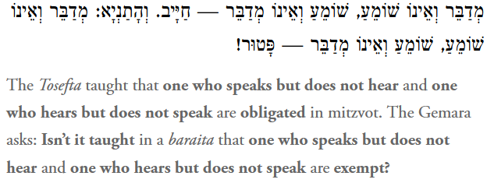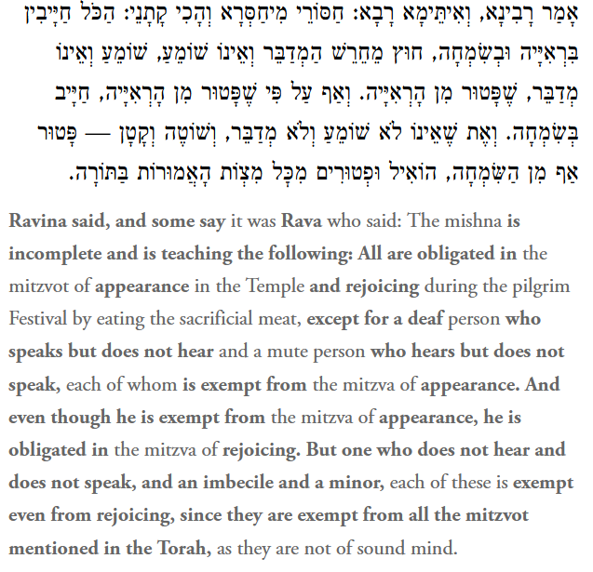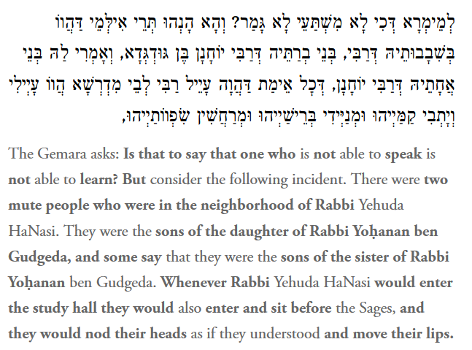
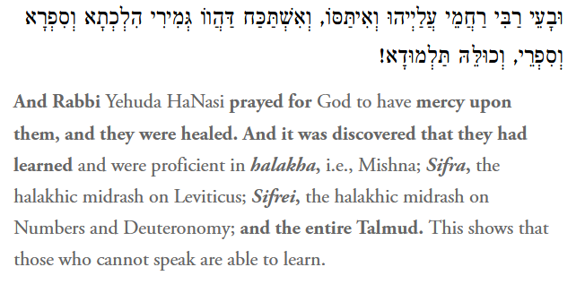
Being allowed to have an Aliyah Latorah.
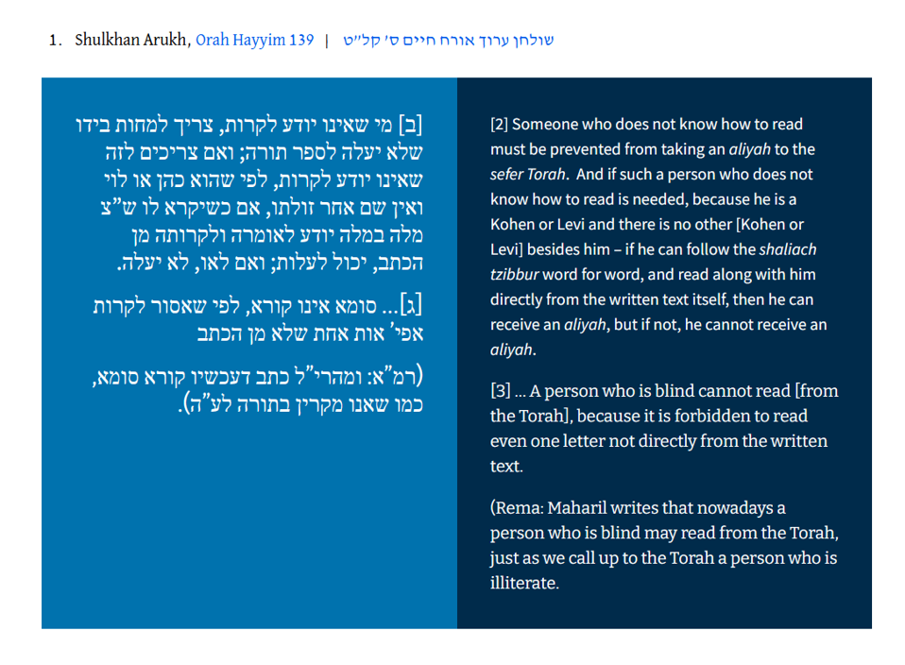
What was the original reason why a blind person was not allowed an Aliyah? Why was that changed?
At the center of a responsum in the book Maseit Binyamin (no. 62), written by Rav Avraham Salnik (Poland, ca. 1550-1620), the permission given to a blind person to be offered an aliyah was couched in different terms.
What reason did he give? How might a person excluded from Torah learning feel?
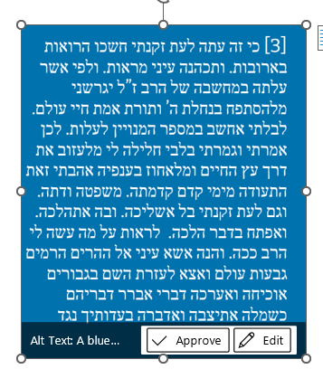
For behold, now in my old age, the sight from my windows has darkened, and my eyes have grown dim from sight (cf., Breisht 27:1). According to what the Rabbi (Yosef Karo) opined, I will be driven away this day from seeking refuge in the inheritance of the Lord (I Samuel 26:19), in the Torah of truth and of eternal life, that I shall not be included in the number of those who are counted to rise up (and read). Therefore, I said and decided in my heart, “God forbid that I should abandon the way of the tree of life, and from my youth I have grasped onto its branches, its laws, and its rule. Even in my old age I shall not cast it off. On its path I will tread.” And I will open with the matter of halakha, to see for what purpose the Rabbi has done such a thing to me. And behold, I will lift my eyes up to the high mountains, the ancient hills, and I will come out to the help of the Lord against the mighty men (Judges 5:23), I will prove and put forth my case… I will establish and “speak regarding Your laws in the presence of kings and not be embarrassed”. (Ps. 119:46)…
For behold, now in my old age, the sight from my windows has darkened, and my eyes have grown dim from sight (cf., Breisht 27:1). According to what the Rabbi (Yosef Karo) opined, I will be driven away this day from seeking refuge in the inheritance of the Lord (I Samuel 26:19), in the Torah of truth and of eternal life, that I shall not be included in the number of those who are counted to rise up (and read). Therefore, I said and decided in my heart, “God forbid that I should abandon the way of the tree of life, and from my youth I have grasped onto its branches, its laws, and its rule. Even in my old age I shall not cast it off. On its path I will tread.” And I will open with the matter of halakha, to see for what purpose the Rabbi has done such a thing to me. And behold, I will lift my eyes up to the high mountains, the ancient hills, and I will come out to the help of the Lord against the mighty men (Judges 5:23), I will prove and put forth my case… I will establish and “speak regarding Your laws in the presence of kings and not be embarrassed”. (Ps. 119:46)…

In legal matters:
Who can be judged to be legally responsible for their actions? Who can be legally responsible to sign financial agreements or documents regarding marriage or divorce? Should the prerequisites be different? The text starts with a Baraita. The Hebrew term Shoteh is problematic and difficult to define. Is the status of a shoteh fixed or fluid? Can it change with time?
Chagigah 3b
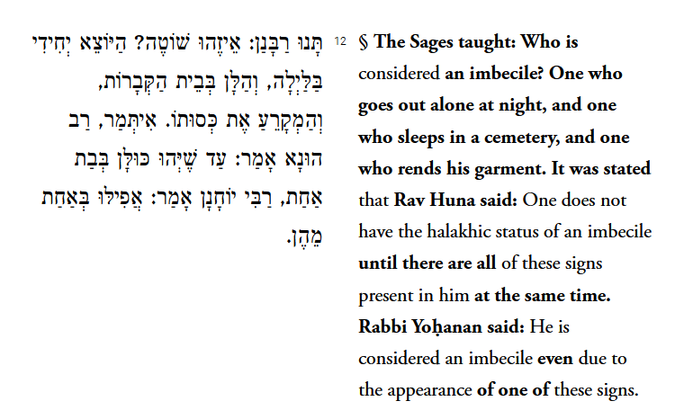
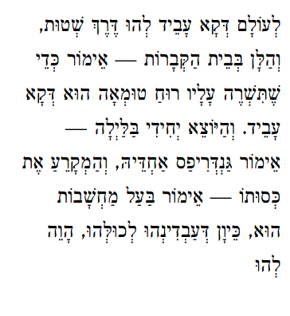
The Gemara answers: Actually, the baraita is referring to one who performs these actions in a deranged manner, but each action on its own could be explained rationally. With regard to one who sleeps in the cemetery, one could say that he is doing so in order that an impure spirit should settle upon him. Although it is inappropriate to do this, as there is a reason for this behavior it is not a sign of madness. And with regard to one who goes out alone at night, one could say that perhaps a fever took hold of him and he is trying to cool himself down. And as for one who tears his garments, one could say that he is a man engaged in thought, and out of anxiety he tears his clothing unintentionally. Despite these possible explanations, since one performed all of these together they are considered

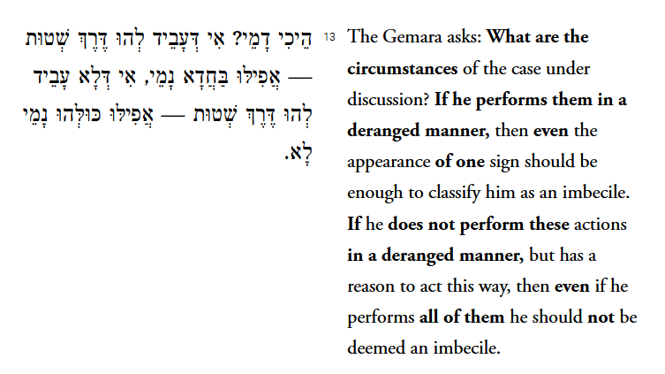
What sort of distress do you think an individual might be feeling if they engage in any of these activities? Do you think the term Shoteh applies to those who are suffering from serious mental illness? Or those with severe intellectual impairments? Where do you draw the line with either of these categories of people?
Maimonides (Moses ben Maimon, commonly known as Maimonides and also referred to by the Hebrew acronym Rambam, was a Sephardic 12th century rabbi and philosopher . He wrote the Mishneh Torah, a compendium of laws from the Talmud, in order to simplify the various rulings in the Talmud. Inevitably, his choice of rulings led to further disputes and discussions!)
Maimonides Mishneh Torah 9:1 Dealing with who are disqualified from being witnesses. In terms of disabilities, we are concerned with sections :d, e, and f but the other categories are fascinating and worthy of debate.
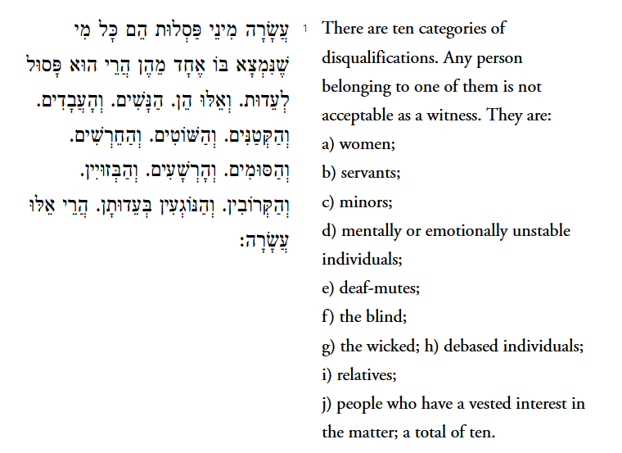
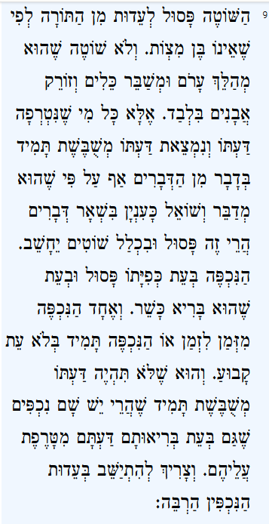
A person who is mentally or emotionally unstable is not acceptable as a witness according to Scriptural Law, for he is not obligated in the mitzvot. We are not speaking about only an unstable person who goes around naked, destroys utensils, and throws stones. Instead, it applies to anyone whose mind is disturbed and continually confused when it comes to certain matters although he can speak and ask questions to the point regarding other matters. Such a person is considered unacceptable and is placed in the category of unstable people.
An epileptic in the midst of a seizure is unacceptable as a witness. When he is healthy, he is acceptable. This applies both with regard to an epileptic who has seizures only infrequently and one who continuously has seizures without having a fixed time for them, provided his mind is not continuously confused. For there are epileptics whose minds are disturbed even when they are healthy. One must ponder much before accepting testimony from epileptics.

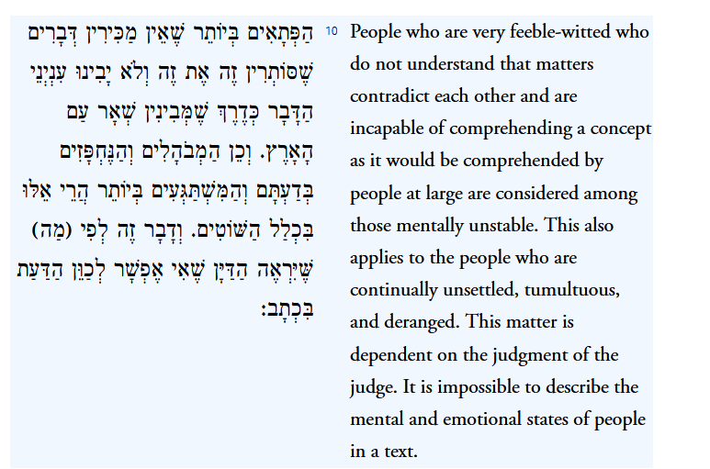
Does Maimonides, who was a doctor, help us define what our reactions should be to the mentally ill or the intellectually impaired? Do we have different criteria these days? What do you make of his final statement? Are there ways that we can rethink the boundaries of 'shoteh' so that we can be more inclusive?
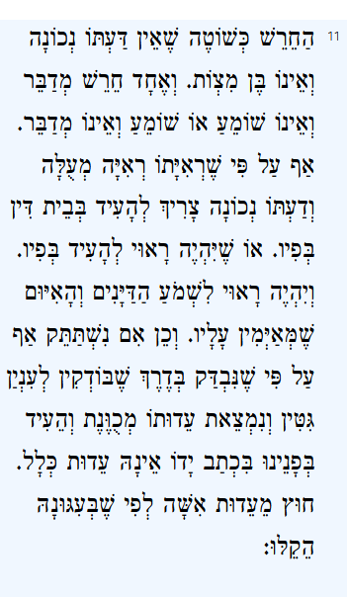
A deaf-mute is equivalent to a mentally unstable person, for he is not of sound mind and is therefore not obligated in the observance of the mitzvot. Both a deaf person who can speak and a person who can hear, but is mute is unacceptable to serve as a witness. Even though he sees excellently and his mind is sound, he must deliver testimony orally in court or be fit to deliver testimony orally and must be fit to hear the judges and the warning they administer to him.
Similarly, if a person loses the ability to speak, even though his intellectual faculties have been checked as a husband is checked with regard to a bill of divorce, he testifies in writing, and his testimony is to the point, it is not accepted at all, except with regard to releasing a women from marriage, for leniency was granted so that women will not be forced to live alone.
In our day, would this be true in our secular courts? Why the leniency for divorce? What is our attitude to the deaf in our communities?

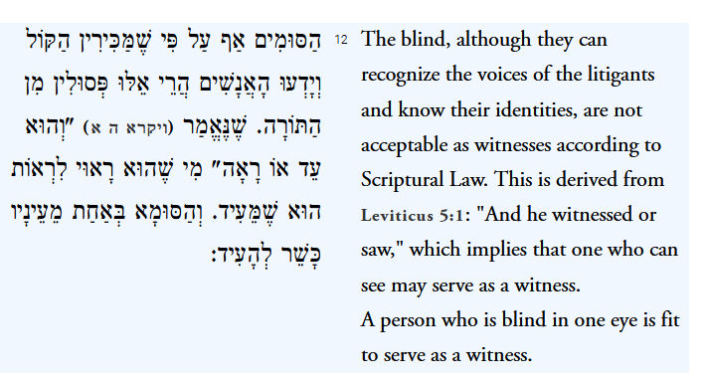
Again, how would our modern secular courts judge the capacity of a blind person to act as a witness?

Texts that affirm the rights and needs of the disabled.
How do each of these texts challenge the texts presented above that limit the perceptions/acceptance of the disabled?
Genesis 1:27
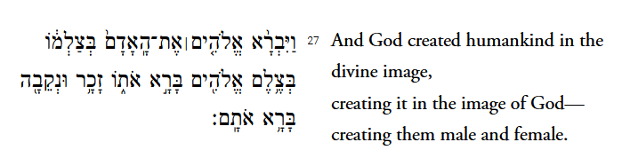
Lev 19:14
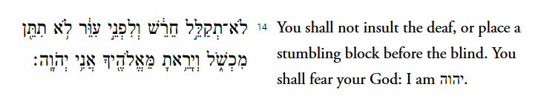
Lev 19:18
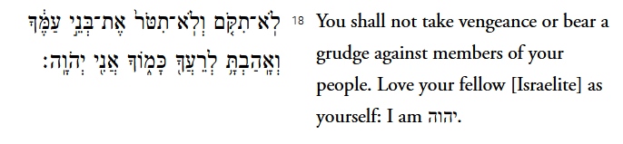
Isaiah 56:7
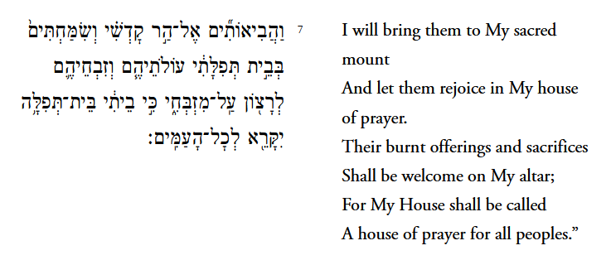
Pirke Avot 4:3
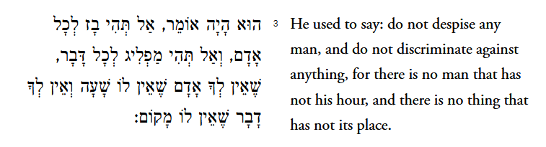
Devarim Rabba 4:4
Rabbi Yehoshua ben Levi said: An image goes before a person, *Human beings are created in the image of God (see Genesis 1:27). The meaning here is that man’s divine image is noticeable to the demons as the man approaches. and the heralds proclaim before him. What do they say? ‘Make room for the image of the Holy One blessed be He.’ See how many guards are protecting you. When [is this so]? When you observe the words of the Torah. I have placed two paths before you – blessing and curse; blessing, if you heed My words, curse, if you do not heed My words.

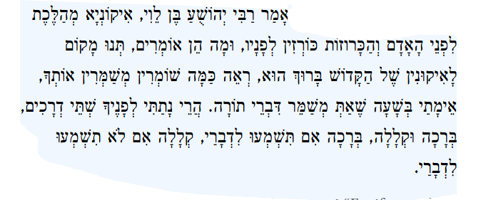

Bikkurim 3:7
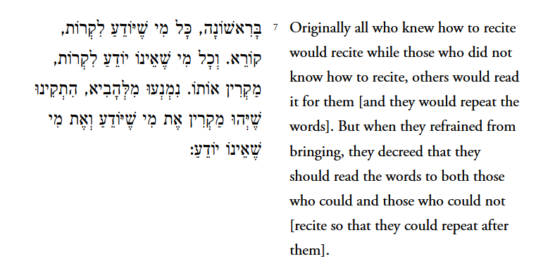
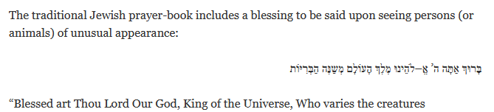
Texts that talk of community…do we need to change?
Jack Reimer - USCJ Blog
If Yitzchak Avinu, Father Isaac, who became legally blind in his old age, were to come into our synagogue and want to daven with us, would we have a large print prayer book available for him?
If Yaakov Avinu, Father Jacob, who was injured in an encounter with a mysterious stranger and limped for the rest of his life as a result, were to come into our synagogue and want an aliyah, would he be able to get up to the bimah here? And if not, if we don’t have a ramp that makes the bimah accessible to the people with disabilities, what would we say to him?
If Moshe Rabeynu, Moses our teacher, who had a speech defect, were to come into our shul and want to read from the Torah that he gave us, could we handle it without becoming embarrassed if he were to stutter?

